Virtues for agents in directed social networks

Mark Alfano, Delft University of Technology & Australian Catholic University

Introduction
In the age of the Internet and other information and communication technologies (ICT), people have increased access to information along multiple dimensions:
- Volume: we have access to more information.
- Velocity: we have access to information more quickly and fluently.
- Veracity: we have access to more accurate information.
- Variety: we have access to more diverse information sources, including people who belong to groups that have historically been ignored or silenced.
- Voice: we have more power to make ourselves heard, as well as to amplify and rebroadcast the messages of others.
In our quest to (help each other to) believe the truth and avoid error (James 1896/1979, Morton 2013), these are welcome developments. It might seem that we are on our way to an epistemic utopia in which we spend less time and effort on basic cognitive tasks, freeing up attention for complex, higher-order, and collaborative inquiry and reasoning about important questions and fraught issues. In this utopia, well-known vices arising from cognitive miserliness (Fiske & Taylor 1984) would be rebaptized as the virtues of cognitive thrift.
There are obvious benefits to distributing one’s cognitive load onto the material and social environment. The availability heuristic (Tversky & Kahneman 1973), for instance, is a form of reliance on sampling the local environment and trusting the reports of (and reports of reports of) others. To employ this heuristic, one infers from the fact that one can more easily think of instances of X than instances of Y to the conclusion that X has a higher value than Y with respect to some relevant criterion. The recognition heuristic (Goldstein & Gigerenzer 2002) is the limit case of the availability heuristic, in which only one of two categories is recognized, leading the agent to infer that the recognized case is higher on the criterion. While people are directly familiar with some of the world, they rely on the testimony of others to mediate their relation to much of the rest of the world (Figure 1).
When these heuristics work well, it is in part because there is a high correlation between the value of the criterion and media coverage of the criterion. This presupposes our epistemic dependence on others to supply true, reliable, and relevant information, a condition that calls for intellectual humility.
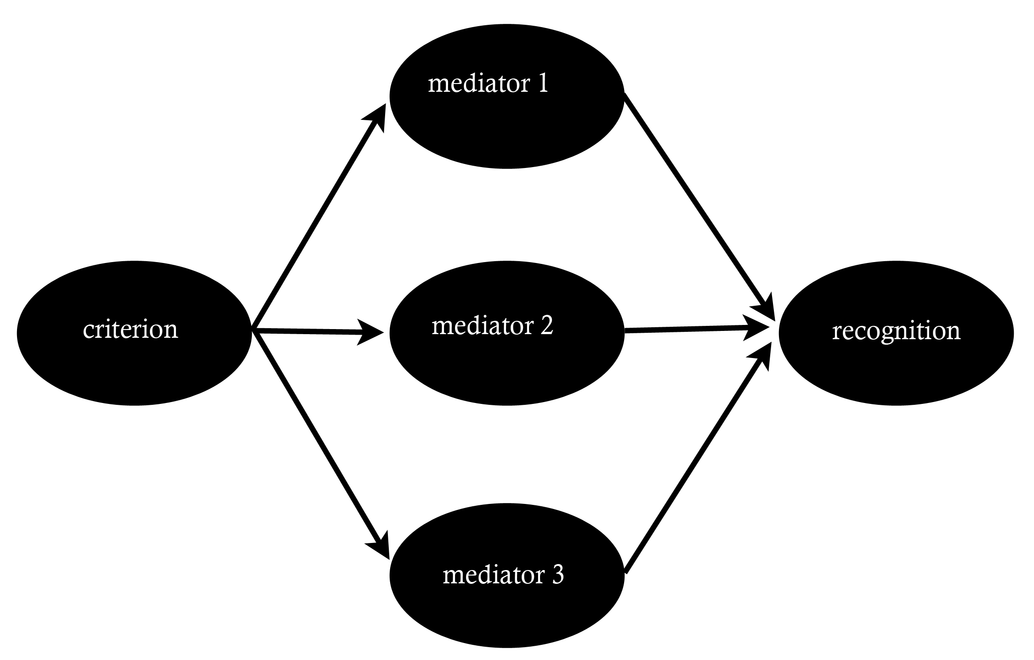 | Figure 1: multiply mediated recognition. The criterion is some salient variable, such as the population of a city or the number of deaths from a particular cause. Mediators include newspapers, television news, social media feeds, and conversations. Recognition refers to one’s ability to recognize or recall instances of the criterion (from Alfano & Skorburg 2016a).

In past and ongoing work, I have visualized the conceptual structure of intellectual humility (Christen et al. forthcoming – Figures 2 and 3), developed a self-report and informant-report scale of intellectual humility’s main dimensions (Alfano et al. forthcoming), and constructed an externalist framework for conceiving of the development, manifestation, and constitution of trustworthiness (Alfano 2013, 2014, 2016a, 2016b; Alfano & Skorburg 2017a, 2017b) and intellectual humility (Alfano 2015a; Alfano & Robinson forthcoming a, forthcoming b).

Figure 2: The structure of IH and closely related constructs (from Christen et al. forthcoming)
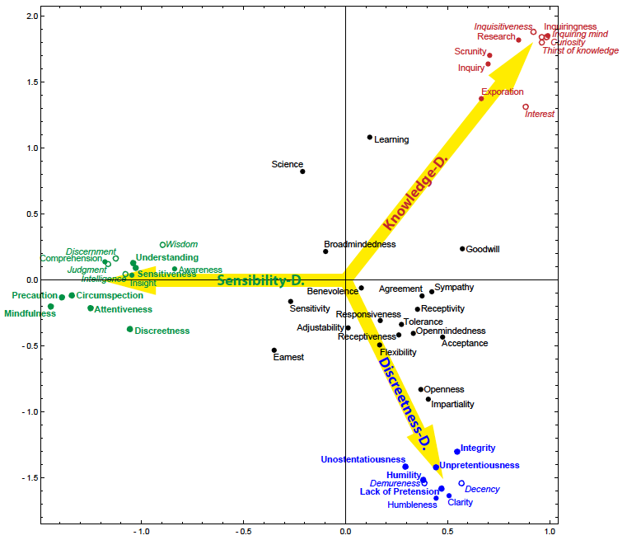
Figure 3: The structure of constructs contrary to IH (from Christen et al. forthcoming)
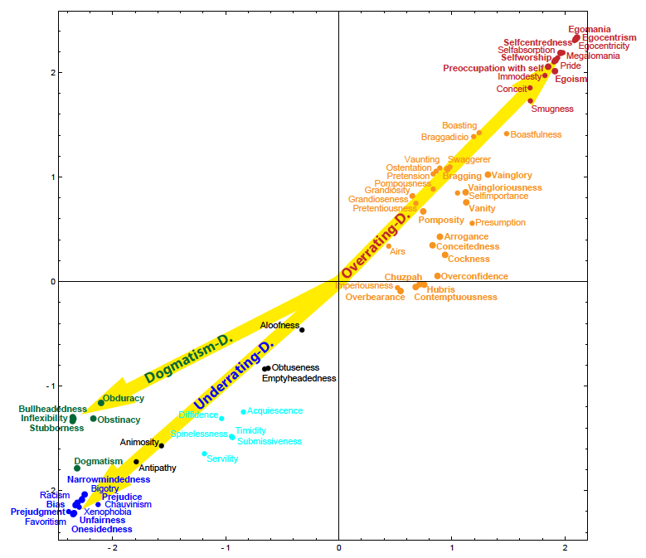

In Alfano & Skorburg (2017b, forthcoming a), I argue that one’s epistemic character can be embedded or extended in one’s material, social, and political context, and that this embedding or extension can be developmental, structural, or constitutive. This position jibes well with recent developments in virtue epistemology that dilate the focus of evaluation from the individual agent to the community (Turri et al. 2017). In Alfano (2017; see also Zollman 2007), I make a first foray into understanding the topology of epistemic communities, asking whether and to what extent it is desirable for trust to be reflexive, symmetric, transitive, and Euclidean.
The astronomical amounts of information available through ICT could only be digested by an immortal, and the speed with which more information is added has led ICT experts to compare keeping up with the latest news and research to “drinking from a fire hose” (Roman & Colle 2003). While there are many accurate sources on the Internet, they must be sifted from the spammers, concern trolls, practical jokers, conspiracy theorists, counterintelligence sock-puppets, and outright liars who also proliferate online. Furthermore, the promise of diverse information sources is easily and often accidentally quashed as we construct “filter bubbles” around ourselves (Pariser 2011). Lotan (2014), a data scientist who specializes in visualizing social networks’ reactions to violent conflict, has argued that, because media are increasingly optimized for engagement rather than truth or reliability, “we are building personalized propaganda engines that feed users content which makes them feel good and throws away the uncomfortable bits.”
In the right material, social, and political context, cognitive miserliness might count as thrift, but cognitively speaking, there are no free lunches. Decreased cognitive demands and increased access come at the price of epistemic vulnerability. If I rely on you for information about appropriate attire for a party, for example, I’m vulnerable to being underdressed or overdressed if your report is misleading. And ignorance can lead to poor decisions about weightier matters: a recent study showed that Americans who were less capable of placing Ukraine on a map of the world were more inclined to prefer military intervention by the USA to overturn the Russian annexation of Crimea (Dropp et al. 2014).
Epistemic vulnerability also affects the availability and recognition heuristics, which are only as reliable as the links among the criterion, media, and recognition (Alfano & Skorburg 2016a). For instance, in 2015, nearly 1146 civilians were killed by the police in the United States, whereas 41 police officers were killed in the line of duty by civilians – a record low. Despite these statistics, between 2014 and 2015 Gallup recorded a seven percentage-point increase in public perception of crime, presumably in part because of sensationalistic crime journalism, filter bubbles on social media, and various other problematic aspects of ICT. Now Donald Trump, after campaigning on the premise that crime is rampant and increasing, is president of the country.
When other people have self-serving interests in my being ignorant or misinformed, I risk much more than embarrassment at wearing the wrong outfit. Moreover, when people who would benefit from my ignorance or error have control over the sources or conduits of information on which I rely, they have the power to systematically influence my knowledge and my thinking. In Alfano & Skorburg (2017a), I class such systematic biases and errors under the rubric of testimonial injustice (Fricker 2007) and demonstrate their prevalence in New York Times coverage of events in Europe versus the rest of the world.
To illustrate, think about reporting on terrorism. When terrorists attacked multiple sites in Paris on November 13, 2015, I knew of it within minutes. I received a push notification on my phone from the Times app with first word of the attacks, and in the following hours I read dozens of reports about the attackers, the victims, the police response, and political implications like the three-month state of emergency declared by François Holland. On a typical day, if you ask me whether there was a terror attack in Paris the day before, I’ll be able to answer confidently. My ongoing connections to the Times, to Vox Media, to Facebook, and to other sources will surely have informed me if there was an attack. Since I don’t regard these media as fake news, I will believe reports they make about attacks in Paris. And if they haven’t reported such an event, my confidence and trust in this testimonial network will lead me to conclude that there must not have been an attack. As Sandy Goldberg (2010) argues, my position in this testimonial network licenses me to make inferences using the “If that were true, I would have heard it by now” heuristic.
By contrast, I only learned several days later of the terrorist bombing that occurred in Beirut on November 12, 2015. And I did so primarily because my one Beiruti friend was complaining on Facebook that it was not fair that the attack in Paris drew the attention of the Western media while the one in Beirut did not. I know a few things about the Beirut attacks, but not nearly as much as I do about the Paris attacks. This is partly because the media I read covered Paris in more detail but also partly because I am more likely to click on and read an article about an attack in Paris than I am to click on and read an article about an attack in Beirut. That I and many others are so disposed is one of the reasons for the disproportionate coverage in the first place, since papers like the Times need to generate enough engagement with their reporting to earn advertising revenue to keep their ventures afloat. On a typical day, if you ask me whether there was a terror attack in Beirut the day before, my confidence in responding will be one-sided. My ongoing connections to the Times, to Vox Media, to Facebook, and to other sources may have informed me of an attack. If they did, I will surely have trusted them, so I will be able to answer affirmatively with conviction. However, they may not have reported such an event even if it did occur, and even if they did report it, I may have missed the (smaller, tucked-away) headline. After all, I don’t read through the whole newspaper every day. Life is short, and philosophy has ruined me for speed-reading. If the sources I trust haven’t reported – or haven’t reported in a sufficiently prominent way to get my attention – an attack in Beirut, I will not have sufficient confidence in my testimonial network to lead me to conclude that there must not have been an attack. Of attacks in Paris, I can say that if they’d happened, I would have heard by now; of attacks in Beirut, not so much.
I live in The Hague, which is a short train ride from Paris. Several of the attackers in Paris hailed from Brussels, which is even closer. Furthermore, at least until the state of emergency was declared, international travel within the Schengen area did not require a passport, so in principle someone who wanted to commit an attack like the one in Paris could easily have done so in my city instead. The same does not hold for Beirut. Given these geographic and political considerations, it makes some sense to focus more of my attention on what happens in Paris than on what happens in Beirut. However, when I consider whether the life of a Parisian is worth more than the life of a Beiruti, whether a Parisian is more worthy of mourning than a Beiruti, or whether Parisians deserve better security than Beirutis simply in virtue of their being Parisians and Beirutis, I want to answer negatively. The systematic bias of the epistemic and testimonial networks into which I’ve plugged myself belies my egalitarian and cosmopolitan values. I may say – both to others and to myself – that every life is on some level equally worthy of concern, protection, and remembrance. I may give lip service to the tradition of zachor. I may even join those who complain about unequal media coverage of the attacks, just one day apart, in Beirut and Paris. But my choices, my attentional dispositions, and the defaults to which I’ve acceded undercut these protestations. My patterns of reading, clicking, sharing stories, remembering, and memorializing suggest that, though I may purport to have egalitarian attitudes about the value of human life, I treat some as more equal than others.
These biases reflect poorly on both my intellectual and my moral character. If I were more responsible, conscientious, curious, and compassionate, I would read more (and more diversely-sourced) media. I am surely not alone in this self-serving hypocrisy. A recent study by data journalist Milo Beckman (2016) found that terrorist attacks in Italy, the United Kingdom, the United Sates, and France were two to six times as likely to be covered in The New York Times as similar attacks in various parts of the Middle East and Asia. In recent work, Gus Skorburg and I demonstrated (Alfano & Skorburg 2017a) even more systematic bias in the Times’s coverage of events of all types (not just terrorist attacks) in Europe versus events in Asia, Africa, and South America. Events in Europe are more likely to be covered in the first place, and the correlation between coverage and Americans’ memory of that coverage is significantly stronger for events that take place in Europe than for events that take place elsewhere. This suggests that, in addition to my failure to embody intellectual virtue, some responsibility must lie in the network of trustful communication into which I am plugged. The same goes for other people as well of course. To a large extent, even if they want to do so, individuals lack sufficient control and power to overcome the biases in their trustful communications networks. No amount of conscientiousness, curiosity, and compassion can utterly defeat the systematic biases of the global media ecosystem we’ve created and which is now shaping our epistemic lives and communities.
If this is on the right track, we can approach the problem via the individual or via the network, understood as an epistemic community whose topology can be mapped and evaluated. Such a community can be modeled as a directed network, in which nodes represent cognitive agents and edges represent lines of trustful communication. Given such a framework, we can then ask two questions. First, holding topology constant, which moral and epistemic dispositions (e.g., trust, distrust, skepticism, curiosity) are conducive to successful inquiry by nodes at different positions within the network? Second, holding the distribution of people’s epistemic dispositions constant, which topologies are more likely to produce epistemic goods (e.g., accuracy, sensitivity, safety) and avoid epistemic ills (e.g., bias, group polarization, dogmatism)? The first question allows that we may be living in very epistemically hostile networks. When the hostility of the network is sufficiently severe and oppressive, the dispositions one needs to thrive may be different from the dispositions one would need to thrive in a friendlier network. Such dispositions would then count as burdened virtues. Lisa Tessman (2005, pg. 95) describes burdened virtues as “traits that make a contribution to human flourishing […] only because they enable survival of or resistance to oppression.”
If, for instance, student victims of rape and sexual assault could reasonably expect that universities offered sufficient institutional protection of victims and prosecution of rapists, then they could rely on such institutions to take their accusations seriously. However, institutional betrayal, rather than support, often seems to be the norm (Smith & Freyd 2014). Many news stories (such as the recent reports about Baylor University in Gottlieb 2016) recount stories of universities failing to properly investigate rape allegations, harassing rape victims, or failing to punish rapists on campus. Such institutional stonewalling prompts the people who are marginalized, victimized, and ignored by those charged with protecting them to turn to gossip as a means of protecting the wellbeing of others. In Alfano & Robinson (forthcoming a), I argue that, for this reason, the disposition to gossip appropriately is a burdened virtue in some social conditions. Along the same lines, Peggy DesAutels (2009) argues that the dispositions needed to be a successful whistleblower in an oppressive corporate or governmental context are burdened virtues. In Alfano (2013), I emphasize the importance of intellectual courage in publicly announcing what one knows or believes in the face of social and institutional pressure to conform or be silent. Such courage relates to the transmission of knowledge and the destruction of ignorance and error in one’s community rather than the seeking of knowledge for the inquirer’s sake.
In cases of both gossip and whistleblowing, X communicates a message to Z without going through Y (i.e., without relying on Y to convey the message and perhaps also without sending Y the message or allowing Y to know that the communication with Z occurred). This is a matter of rewiring a defective epistemic network by adding a line of trustful communication to it. There are also cases in which the virtuous response to finding oneself in a defective epistemic network is rewiring the network by destroying a line of communication in it. If we could get Americans to stop watching Fox News and reading Breitbart, we would improve a seriously defective epistemic network. This could be done through something like censorship of hate speech, targeting the communication itself. Since the arrows in the directed network represent trustful communication, we can target problems by adding trust, adding communication, or destroying trust. Destroying communication is drastic. Censorship falls under this label. That’s why many would prefer to persuade Baby Boomers not to trust Breitbart instead of just cutting off their Internet connections. But that shouldn’t lead us to underplay the severity of destroying trust.
The discussion thus far may seem to indicate that our topic has drifted from the framework of virtue theory to that of consequentialism. While I take no issue with supplementing with consequentialist considerations, I contend that we need to keep the virtue perspective. This is because being a virtuous agent in the kind of network we are envisaging requires ongoing diligence, not just a single act of rewiring. A virtuous communicator not only speaks, listens, repeats, and passes along what she’s heard. She also monitors the kind of network she’s in, as well as the kind of network others are in and think they’re in. Being disposed to detect severe problems in one’s epistemic network and to try to remedy such problems when possible is an intellectual virtue (or, more likely, a family of related intellectual virtues) and – when the problematic features of the network involve oppression – also a burdened virtue.
These reflections on rewiring emphasize the epistemic harms and benefits to (potential) recipients of trustful communication. We can also weigh the epistemic harms and benefits to (potential) senders of trustful communications. Consider, for example, Jeffrey Blustein’s discussion of the testimonial interdependence of speaker and hearer. He argues that “bearing witness [to the death of a loved one or an atrocity] is associated with finding and registering one’s ‘voice’, that is, with telling one’s own story and having it heard in the right way” (p. 302, emphasis mine). He claims, moreover, that “bearing witness is a type of address to an audience in need, crucially dependent on trust in the witness, who has the relevant authority or competence to serve as a witness” (p. 305, emphasis mine). If the bereaved does not trust his community to respond appropriately to his grief or trauma, he may not bear witness in the first place. This is one reason why victims of sexual assault often do not report their abuse (Sable et al. 2006). Elizabeth DeVita-Raeburn, the sister of the famous “boy in the bubble” who suffered and died from aplastic anemia in the 1970s, gives poignant expression to this problem in The Empty Room (2004). Drawing on dozens of interviews with other bereaved siblings, she quotes “Amber,” whose younger brother died in a car crash when she was nineteen, saying “I felt like there were a lot of outlets for my parents, but I felt like there was nothing for me. People would interrupt my grief to say, ‘Boy, that must be really hard for your parents’” (p. 50). When grief is interrupted in this way or met with institutional betrayal, people who have experienced loss and trauma tend to withdraw into their own suffering. They sever whatever bonds of trustful communication formerly connected them to the community that trivialized or exploited their grief, and the process of mourning must be undertaken alone and often ineffectually.
This pattern is perhaps even more familiar to combat veterans than to civilians. In Achilles in Vietnam (1995, p. 4), Veterans’ Administration psychiatrist Jonathan Shay says that, for his patients, “healing from trauma depends upon communalization of the trauma – being able safely to tell the story to someone who is listening and who can be trusted to retell it truthfully to others in the community.” Listening in a perfunctory way, he claims, “destroys trust.” Veterans in a civilian society face a nearly-insurmountable problem in this regard because people who have never experienced anything like combat tend to find it difficult to empathize and may respond instead with disbelief, shock, or blame. This all-too-human reaction, like the reaction to Amber quoted in the previous paragraph, leads some veterans to wall themselves off from civilian society. As Shay says, it destroys trust. He goes on to argue that “Any blow in life will have longer-lasting and more serious consequences if there is no opportunity to communalize it. This means some mix of formal social ceremony and informal telling of the story with feeling to socially connected others” (p. 39). Although he does not give a detailed explanation for this psychological generalization, Shay does offer a topological insight in Odysseus in America (2003), in which he argues for the importance of what he calls “social trust.” Such trust, he says
requires at least three people. Dyadic trust between two people, no matter how many times it is pair-wise created, does not make a community. A community begins with the addition of the third person, and with the belief of each individual that when alone together the other two will continue to safeguard the interests of each even when that person is absent. (pp. 175-6)
To enrich the account of social trust and shed some light on what would count as virtuous (dis)trust in a defective epistemic network, we can distinguish some important structural features of epistemic networks. As McLoed (2015) points out in her entry on trust in the Stanford Encyclopedia of Philosophy, one of the central philosophical questions about trust is under what conditions it is warranted. We can expand this question to ask what reasons there might be to enrich a network of trustful communication by extending it to a new member or by increasing its density by establishing new connections within it, as well as what reasons there might be to retract or fracture a network of trustful communication by removing a link.
To answer these questions, we need to reflect on the topology of such networks. Four of the most important properties in such a network are symmetry (being talked to by those you talk to), reflexivity (talking to yourself), Euclideanism (the people you talk to also talking to each other), and transitivity (passing on messages that are first transmitted to you). Figure 4 illustrates a minimal network, in which A talks to B, B doesn’t talk to A, neither A nor B talks to themselves, and no one else is involved.

Figure 4: Basic dyadic trustful communication

In a minimal network like this, testimonial knowledge can be transferred from A to B. One way to enrich the minimal network is to add a link from B to A, making them equal partners (figure 5).

Figure 5: Symmetric trustful communication

Another way to enrich a network is to add a reflexive link, allowing agents to talk to themselves and trust themselves (figure 6).

Figure 6: Symmetric and reflexive trustful communication
At first blush, it might seem that the reflexive links don’t accomplish anything. What do I learn when I tell myself something? Turning the question around, though, we might ask: why do people talk to themselves all the time? I suggest that one of the functions of talking to oneself is to improve the robustness of memories. If I tell myself something, I’ll be more likely to remember it than if I don’t tell myself the same thing. This kind of aid to memory is enhanced when I reify my reflexive speech in writing or memorials that stand as external reminders of what I once thought. Speaking to oneself also expresses self-trust that might be needed in a hostile epistemic network. There is a remarkable near-consensus that, unless you have particular reasons to the contrary, you ought to trust yourself. For example, Pasnau (2015) argues that self-trust justifiably influences how we should react to peer disagreement. Lehrer (1997) argues that self-trust grounds reason, wisdom, and knowledge. Govier (1993) argues that self-trust grounds autonomy and self-respect. Jones (2012) positively evaluates self-trust from a feminist perspective. And Goldberg (2013) argues that self-trust is a good model for trust in others. Medina (2012) has also given an account of intellectual humility as critical awareness of one’s cognitive limitations and blind-spots.
Consider next networks of at least three individuals. What reasons might there be to enrich such a network so that it is (closer to being) Euclidean? We can begin with the simple case illustrated in figure 7.

Figure 7: Symmetric but non-Euclidean trustful communication
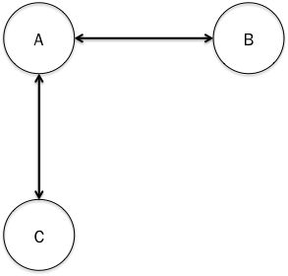

Under what conditions is it warranted for B and C to engage in trustful communication? In many cases, B and C will have good reason to establish relations of trustful communication with one another. Indeed, this is what happens in cases of virtuous gossip and whistleblowing. To see why, consider the somewhat more complex “star-network” pictured in figure 8.

Figure 8: Star-network
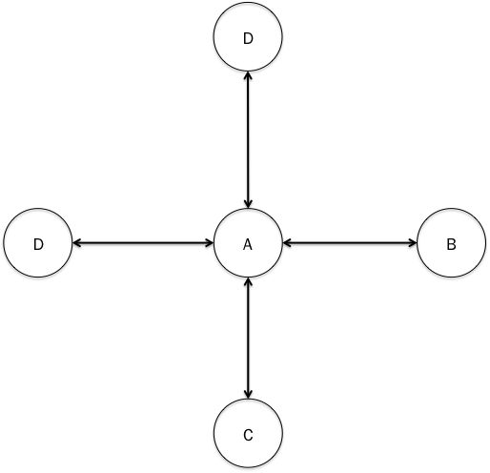

In his seminal work on social networks, Freeman (1978) described the star-network, in which all other nodes are connected to a single central hub but not to each other, as the most unequal topology possible. Sexual predators and their targets often form a star-network, with the predator at the center and the victims on the points of the star. This keeps the victims from effectively communicating with one another and coordinating or cooperating against the predator (Fire et al. 2012). Star-networks are also associated with financial fraud (˘Subelj et al. 2011), academic fraud (Callaway 2011), and terrorist activities (Reid et al. 2005; Krebs 2002). In a recent paper, Savage et al. (2014) categorize star-networks and near-star-networks in an effort to make their online detection more effective. Mutual and common knowledge, especially about problematic behavior by the hub of a community, is promoted by the gossip that occurs in Euclidean connections in that community. This is presumably why a wannabe strongman like Donald Trump has forbidden the US National Parks Service from communicating with the public, and why the Parks Service and many other government agencies (seem to) have created alternative and rogue accounts on Twitter.
Naturally, not every relationship is in imminent danger of turning into sexual harassment, fraud, terrorism, or a Trump presidency, but for many sensitive relationships, these considerations suggest that making networks more Euclidean is warranted and may increase warranted trustful communication with other members of the network (figure 9).

Figure 9: Symmetric and Euclidean trustful communication
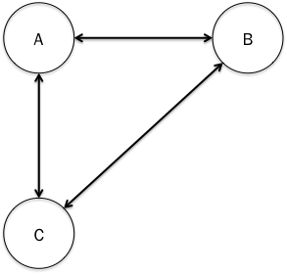

All that said, in some cases we reasonably aim to produce star-networks that are also highly regulated and in which the hub is held accountable. Think of a priest who takes confession, a therapist who has clients who (might) know each other, or a journal editor who attempts to ensure anonymous review of submissions. Severing or preventing the establishment of Euclidean trustful communication has a role to play as well, even though it greatly empowers whoever occupies the hub of the network.
This leaves us with transitivity: extending trustful communication out further into a network. What reasons might there be to do this? If the network is already characterized by symmetry and reflexivity, then adding transitivity will make trustful communication an equivalence relation in the community in question, as illustrated in figure 10.

Figure 10: Trustful communication as an equivalence relation
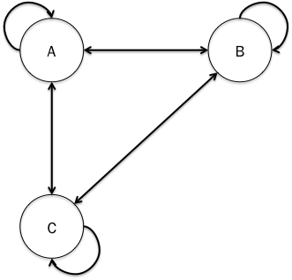
As we saw above in Shay’s definition of social trust, he believes on the basis of clinical experience that recovery from grief and trauma is only possible in a context where trust extends transitively at least one step. These observations suggest that we have reason to find or construct communities that have this characteristic. Shy of such a highly demanding approach to transitivity, we might ask about extending trustful communication one or two steps out into a community (figure 11). What reasons are there for B to pass along to D what C has said? What reasons are there for D to trust B’s communications about what C has said?

Figure 11: Transitive extension of trustful communication
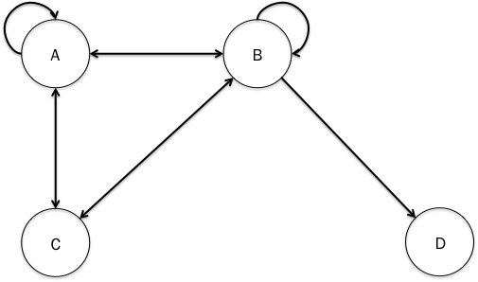

The importance of repeating to third parties what first parties have said is reified in social phenomena like sharing posts on Facebook and retweeting (not to mention asking others to share one’s posts or retweet what one tweets). To share or retweet – or to signal-boost a message in a more old-fashioned way – is to make an effort to ensure that a message is heard. Doing so can indicate endorsement of, condemnation of, or mere interest in what is passed along. It can more or less accurately (versus noisily or misleadingly) pass along the message. And it can do so either with an accurate indication of where the message originated, no indication of where the message originated, or a misleading or false indication of where the message originated (what we might call the groundwork for the morals of metadata). Faith communities in which presumed-reliable chains of testimony transmit revelation and other teachings (e.g., hadith) essentially depend on the transitivity of trustful communication. This insight goes back at least to Avicenna (Black 2013). Secular communities, including scientific communities, especially large interdisciplinary collaborations, also depend on the trustworthiness and trustingness of their members (Hardwig 1991).
Building on this idea, I propose a new holistic framework for testimonial ethics, in which distinct virtues attach to each of these potential communicative roles. Roughly and as a first pass, we might characterize these virtues as follows: one is a virtuous source/receiver/conduit/echoer of testimony just in case one excellently or admirably occupies the role in question. I suggest that we taxonomize virtues (and their opposing vices) for agents in directed social networks into four families: source virtues, receiver virtues, conduit virtues, and echoic virtues. While some of these virtues are well-studied, others have been scanted.
Source virtues: These are the dispositions that make someone an excellent primary source of trustful communication. In virtue theory and social epistemology, the virtues of speakers and other sources of testimony have received a great deal of attention. Such virtues include honesty, sincerity, trustworthiness, and intellectual generosity (Roberts & Wood 2007) in the communication of one’s knowledge and evidence. They also include the disposition to adhere for its own sake to something like Grice’s (1975) cooperative principle and the subordinate maxims of quantity, quality, relation, and manner. For instance, violations of the maxim of quantity include both intellectual stinginess and intellectual profligacy, which result in such diverse manifestations of testimonial vice as lying by omission, conversational terrorism, mansplaining, and trolling. Source virtues also relate to the degree to which one is disposed to make assertions privately or publicly, with the latter serving as a basis for mutual and common knowledge. In addition, there are the source virtues associated with monitoring one’s audience and responding appropriately. A virtuous source seeks an audience for trustful communication about some topics with some people and makes an effort not to engage in trustful communication about some topics with other people. A good source knows the structure of her epistemic network and sometimes rewires it to make it more robust or less corrupt.
Receiver virtues: These are the dispositions that make someone an excellent recipient of trustful communication. Such virtues include credulity, trust, skepticism, and what Fricker (2007) calls testimonial justice, which is a disposition to afford appropriate credence to someone’s testimony and to resist unfair biases based on epistemically irrelevant features of the source of testimony, such as their gender, race, ethnicity, religion, and disability status. Testimonial justice has received most attention when it opposes credibility deficits, but it is also important to avoid systematic credibility excesses, especially when these are likely to confirm illegitimate privileges or lead to serious extrinsic harms (Medina 2012). Being a virtuous receiver will also presumably involve a disposition to ask (the right) questions (of the right people, at the right time). A good receiver embodies the interrogative analogue of Grice’s maxims of assertion. They ask about things that they need to know, should know, or at least may know. They ask for as much detail as is required. They ask relevant questions. And they ask in an appropriate manner. In addition, the possibility of overhearing and conceptually similar episodes indicates that there may be a virtue of refusing to receive testimony, at least from certain senders in certain conditions. Finally, just as there is a virtue associated with monitoring and being disposed to rewire a network in which one occupies a source role, so there are is a virtue associated with monitoring and being disposed to rewire a network in which one occupies a receiver role.
Conduit virtues: These are the dispositions that make someone an excellent relayer of trustful communication. Unlike source and receiver virtues, conduit virtues have received almost no attention from philosophers. The exceptions include the papers mentioned above about the disposition to gossip well (Alfano & Robinson forthcoming a), to be a fair journalist (Alfano & Skorburg 2017a), and to be an effective whistleblower (DesAutels 2009). Outside of philosophy, conduit virtues have been theorized in connection with diverse goods. As I mentioned above, Shay (1994, 2003), a clinical psychiatrist, has argued that recovery from trauma, moral injury, and grief takes place only when one tells one’s story to someone who can be trusted to retell it to others. And Eli Pariser (2011), a data scientist, has argued that, unless the algorithms that determine which media and social media people encounter are re-written, we are liable to end up in self-contained “filter bubbles” that never challenge our pre-existing beliefs. The disposition to monitor the (potential) conduits in one’s network and rewire the network such that they function to better epistemic effect would be another such virtue.
Examples of conduit virtues in the wild include the “amplification” strategy adopted by the women staffers in Barack Obama’s White House who made a point of repeating what each other said during meetings to make sure that it was listened to and correctly attributed, Kimberlé Crenshaw’s #SayHerName movement, and outrage over Donald Trump’s retweeting a quotation from Mussolini and Donald Trump Jr’s retweeting a white supremacist meme.
Echoic virtues: These are the dispositions that make someone an excellent reiterator of trustful communication back to its source. It might seem that there is little point in echoing back what someone has said, but there are multiple reasons to think otherwise. As I mentioned above, we can repeat things to ourselves to strengthen our memories. We can also repeat (some of) what someone else has said back to them. Doing so presumably also helps both us and them remember. It can also provide critical distance from our thoughts, helping us to put them in order and restructure them. Andy Clark (2002) argues that the ability to engage in multiple rounds of such feedback (which can also be technologically mediated) is part of what makes human cognition special. For instance, we are all familiar with using a trusted other as a sounding board, who can repeat back to us in charitable paraphrase what we’ve said. Such exchanges help us to clarify and crystalize our beliefs, and may be essential to self-knowledge and self-criticism. As David Wong (2006, p. 136) puts it, hearing our words repeated back by others can
help to shape and crystallize traits and desires that are especially congruent with our most important ends. Or rather, there are often times when increased self-knowledge merges with the crystallization of a trait or desire – when, for instance, understanding oneself better is at the same time making more determinate tendencies and impulses within one’s character that are in some degree inchoate. I have in mind ways that others can help us through some insight as to what our “real” feelings and motivations are, where that insight is partly an accurate portrayal of what is already there but also helps to reinforce and make more determinate what those feelings and motivations are. A friend who points out to a person that she is more compassionate than she understands herself to be, who points to certain recurring instances of compassionate behavior as evidence, may not just be pointing to what is already there but crystallizing and making more motivationally salient that trait in his friend.
Such phenomena are also harnessed in clinical psychology. For example, Phil Fisher (Fisheret al. 2016) employs the Filming Interactions to Nurture Development (FIND) methodology with parents and other caretakers of high-risk children. The basic idea with this methodology is to videotape caregivers interacting with their children, then edit the video down to include only the healthiest reactions, which are then shown to the caregiver along with an explanation and words of praise.
As I argue in Alfano (2015b, forthcoming; see also Doris 2015), Friedrich Nietzsche identifies two main channels through which such dialogical processes flow (Human, All-Too-Human 51; Daybreak 105, 201, 248; Gay Science 21, 40, 58; Beyond Good and Evil 42, 44, 261; Genealogy of Morals I:2, I:6). On the one hand, sometimes a person announces what she is (i.e., what her values, motives, concerns, or drives are), and that announcement meets with social acceptance; on the other hand, sometimes someone else announces what the person is, and she accepts the attribution. Such bid-and-accept patterns can be iterated. X could describe herself has embodying value V, to which Y responds by pointing to evidence (e.g., in her past behavior) that she actually embodies value V*, to which X responds by pointing to evidence that she actually embodies V†, and so on. Moreover, the negotiation needn’t be so explicit. X could instead tell a story that represents herself as embodying V, to which Y responds by asking a question that presupposes that she embodies V*, to which X responds by telling another story that represents herself as embodying V†. The kind of person or self that emerges from such feedback loops is reflected or echoed rather than reflective and transparent.
In addition, such echoing activities can foster solidarity and contribute to meaning-making. Hearing our stories affirmed and repeated back to us assures us that they make sense. By reifying and externalizing our experiences, then, echoic virtues contribute to what Fricker (2007) calls hermeneutic justice, which involves having adequate conceptual and linguistic resources to make sense of one’s own experiences. Finally, just as there is a virtue associated with monitoring and being disposed to rewire one’s network to become a better source, receiver, or conduit, so there is a virtue associated with monitoring and being disposed to rewire one’s network to become a better echo. This could involve learning to journal or use a diary, which James Pennebaker (2011) has shown can support better mental health under certain conditions. It could also involve resolving to elicit and echo back messages from another person, or to cut off relations with someone who systematically echoes a distorted and harmful version of yourself back to you.
These thumbnail sketches of source, receiver, conduit, and echo virtues need to be fleshed out in more detail. It would also be worthwhile to operationalize and measure them with any eye to articulating promising ways to better develop them or automate them in digital communications networks.

References
Alfano, M. (forthcoming). The Nietzschean precedent for anti-reflective, dialogical agency. Behavioral and Brain Sciences.
Alfano, M. (2017). The topology of communities of trust. Russian Sociological Review, 15(4): 30-56.
Alfano, M. (2016a). Moral Psychology: An Introduction. Polity.
Alfano, M. (2016b). Friendship and the structure of trust. In A. Masala & J. Webber (eds.), From Personality to Virtue: Essays in the Psychology and Ethics of Character, pp. 186-206. Oxford University Press.
Alfano, M. (2015a). Becoming less unreasonable: A reply to Sherman. Social Epistemology Review and Reply Collective, 4(7): 59-62.
Alfano, M. (2015b). How one becomes what one is called: On the relation between traits and trait-terms in Nietzsche. Journal of Nietzsche Studies, 46(1): 261-9.
Alfano, M. (2014). What are the bearers of virtues? In H. Sarkissian & J. C. Wright (eds.), Advances in Experimental Moral Psychology, pp. 73-90. Continuum.
Alfano, M. (2013). Character as Moral Fiction. Cambridge University Press.
Alfano, M., Iurino, K., Stey, P., Robinson, B., Christen, M., Yu, F., & Lapsley, D. (forthcoming). Development and validation of a multi-dimensional measure of intellectual humility. PLoS ONE.
Alfano, M. & Robinson, B. (forthcoming a). Gossip as a burdened virtue. Ethical Theory and Moral Practice.
Alfano, M. & Robinson, B. (forthcoming b). I know you are but what am I? Anti-individualism about intellectual humility and wu-wei. Logos & Episteme.
Alfano, M. & Skorburg, A. (2017a). Extended knowledge, the recognition heuristic, and epistemic injustice. In D. Pritchard, J. Kallestrup, O. Palermos, & A. Carter (eds.), Extended Knowledge. Oxford University Press.
Alfano, M., & Skorburg, A. (2017b). The embedded and extended character hypotheses. In J. Kiverstein (ed.), Handbook of Philosophy of the Social Mind. Routledge.
Alfano, M. & Skorburg, A. (forthcoming). Psychological science and virtue epistemology: Intelligence as an interactionist virtue. In H. Battaly (ed.), The Routledge Handbook of Virtue Epistemology. Routledge.
Beckman, M. (2016, July 19). Which countries’ terrorist attacks are ignored by the U.S. media? Fivethirtyeight. URL = <http://fivethirtyeight.com/features/which-countries-terrorist-attacks-are-ignored-by-the-u-s-media/>. Accessed 20 July 2016.
Black, D. (2013). Certitude, justification, and the principles of knowledge in Avicenna’s epistemology. In P. Adamson (ed.), Interpreting Avicenna, pp. 120-42. Cambridge University Press.
Blustein, J. (2008). The Moral Demands of Memory. Cambridge University Press.
Callaway, E. (2011). Report finds massive fraud at Dutch universities. Nature, 479(7371), 15.
Chinnery, A. (2013). On epistemic vulnerability and open-mindedness. Philosophy of Education, 63-66.
Christen, M., Alfano, M., & Robinson, B. (forthcoming). A cross-cultural assessment of the semantic dimensions of intellectual humility. AI & Society.
Clark, A. (2002). Towards a science of the bio-technological mind. International Journal of Cognition and Technology, 1(1): 21-33.
DesAutels, P. (2009). Resisting organizational power. In L. Tessman (ed.), Feminist Ethics and Social and Political Philosophy: Theorizing the Non-Ideal. Springer.
DeVita Raeburn, E. (2004). The Empty Room: Surviving the Loss of a Brother or Sister at Any Age. Scribner.
Dixon, R. & Gould, O. (1996). Adults telling and retelling stories collaboratively. In P. Baltes & U. Staudinger (eds.), Interactive Minds: Life-Span Perspectives on the Social Foundation of Cognition. Cambridge University Press.
Doris, J. (2015). Talking to Ourselves: Reflection, Ignorance, and Agency. Oxford University Press.
Dropp, K., Kertzer, J., & Zeitzoff, T. (2014). The less Americans know about Ukraine’s location, the more they want U.S. to intervene. < http://www.washingtonpost.com/blogs/monkey-cage/wp/2014/04/07/the-less-americans-know-about-ukraines-location-the-more-they-want-u-s-to-intervene>. Accessed 20 July 2016.
Fire, M., Katz, G., & Elovici, Y. (2012). Strangers intrusion detection – detecting spammers and fake profiles in social networks based on topology anomalies. Human Journal, 1(1): 26-39.
Fisher, P., Frenkel, T., Noll, L., Berry, M., & Yockelson, M. (2016). Promoting healthy child development via a two-generation translational neuroscience framework: The Filming Interactions to Nurture Development video coaching program. Child Development Perspectives, 10(4): 251-6.
Fiske, S. & Taylor, S. (1984). Social Cognition. Addison-Wesley.
Freeman, L. (1978). Centrality in social networks conceptual clarification. Social Networks, 1: 215-39.
Fricker, M. (2007). Epistemic Injustice: Power and the Ethics of Knowing. Oxford: Oxford University Press.
Gilson, E. (2011). Vulnerability, ignorance, and oppression. Hypatia, 26(2): 308-332.
Goldberg, S. (2010). Relying on Others: An Essay in Epistemology. Oxford University Press.
Goldberg, S. (2013). Self-trust and extended trust. Res Philosophica, 90(2): 277-92.
Goldstein, D. G., & Gigerenzer, G. (2002). Models of ecological rationality: The recognition heuristic. Psychological Review, 109(1), 75–90.
Gottlieb, J. (2016, October 28). Report: Baylor regents say 19 football players accused of sexual assault since 2011. The Washington Post. <URL = https://www.washingtonpost.com/news/early-lead/wp/2016/10/28/report-baylor-regents-say-19-football-players-accused-of-sexual-assault-since-2011/>. Retrieved 17 November 2016.
Govier, T. (1993). Self-trust, autonomy, and self-esteem. Hypatia, 8(1): 99-120.
Grice, H. P. (1975). Logic and conversation. In P. Cole & J. Morgan (eds.), Syntax and Semantics 3: Speech Acts. New York: Academic Press.
Hardwig, J. (1991). The role of trust in knowledge. The Journal of Philosophy, 88(12): 693-708.
James, W. (1896/1979). The will to believe. In Burkhardt et al. (eds.), The Will to Believe and Other Essays in Popular Philosophy, pp. 291-341. Harvard University Press.
Jones, K. (2012). The politics of intellectual self-trust. Social Epistemology, 26(2): 237-51.
Kramer, S., Goré, R., & Okamoto, E., (2010). Formal definitions and complexity results for trust relations and trust domains fit for TTPs, the Web of Trust, PKIs, and ID-based cryptography. Logic Column of ACM SIGACT News.
Krebs, V. (2002). Mapping networks of terrorist cells. Connections 24(3): 43-52.
Lehrer, K. (1997). Self-Trust: A Study of Reason, Knowledge, and Autonomy. Oxford University Press.
Lotan, G. (2014). Israel, Gaza, war & data: Social networks and the art of personalizing propaganda. The World Post. < http://www.huffingtonpost.com/gilad-lotan/israel-gaza-war-social-networks-data_b_5658557.html>
McLeod, C. (2015, fall edition). Trust. The Stanford Encyclopedia of Philosophy, URL = <http://plato.stanford.edu/archives/fall2015/entries/trust/>. Accessed 1 September 2016.
Medina, J. (2012). The Epistemology of Resistance: Gender and Racial Oppression, Epistemic Injustice, and Resistant Imaginations. Oxford University Press.
Morton, A. (2013). Bounded Thinking: Intellectual Virtues for Limited Agents. Oxford University Press.
Olsson, E. (2013). A Bayesian simulation model of group deliberation and polarization. In F. Zenker (ed.), Bayesian Argumentation: The Practical Side of Probability. Springer.
Pariser, E. (2011). The Filter Bubble: What the Internet is Hiding from You. New York: Penguin Press.
Pasnau, R. (2015). Disagreement and the value of self-trust. Philosophical Studies, 172(9): 2315-39.
Pennebaker, J. (2011). The Secret Life of Pronouns: What Our Words Say About Us. Bloomsbury.
Reid, E., Qin, J., Zhou, Y., Lai, G., Sageman, M., Weimann, G., Chen, H. (2005). Collecting and analyzing the presence of terrorists on the web: A case study of jihad websites. In: Kantor, P., Muresan, G., Roberts, F., Zeng, D.D., Wang, F.Y., Chen, H.C., Merkle, R.C. (eds.), Intelligence and Security Informatics. Berlin: Springer.
Roberts, R. & Wood, J. (2007). Intellectual Virtues: An Essay in Regulative Epistemology. Oxford University Press.
Roman, R. & Colle, R. (2003). Content creation for ICT development projects: Integrating normative approaches and community demand. Information Technology for Development, 10(2): 85-94.
Sable, M., Danis, F., Mauzy, D., & Gallagher, S. (2006). Barriers to reporting sexual assault for women and men: Perspectives of college students. Journal of American College Health, 55(3): 157-62.
Savage, D., Zhing, X., Yu, X., Chou, P., & Wang, Q. (2014). Anomaly detection in online social networks. Social Networks, 39(4): 62-70.
Shay, J. (2003). Odysseus in America: Combat Trauma and the Trials of Homecoming. Scribner.
Shay, J. (1994). Achilles in Vietnam: Combat Trauma and the Undoing of Character. Simon &
Smith, C. P. & Freyd, J. (2014). Institutional betrayal. American Psychologist, 69(6): 575-87.
˘Subelj, L., Furlan, U., & Bajec, M. (2011). An expert system for detecting automobiles insurance fraud using social network analysis. Expert Systems Applications, 38(1): 1039-52.
Tessman, L. (2005). Burdened Virtues: Virtue Ethics for Liberatory Struggles. Oxford University Press.
Turri, J., Alfano, M. & Greco, J. (2017). Virtue epistemology. Stanford Encyclopedia of Philosophy.
Tversky, A. & Kahneman, D. (1973). Availability: A heuristic for judging frequency and probability. Cognitive Psychology, 5: 207-32.
Zollman, K. (2007). The communication structure of epistemic communities. Philosophy of Science, 74(5): 574-87.

This research was funded by a grant from the Templeton Foundation.
This list is inspired by though different from several other similar lists kicking around the Internet on blogs and consulting firm websites.
For more on the notion of epistemic vulnerability, see Gilson (2011) and Chinnery (2013).
http://www.theguardian.com/us-news/ng-interactive/2015/jun/01/the-counted-police-killings-us-database. Accessed 15 September 2015.
https://www.fbi.gov/news/pressrel/press-releases/fbi-releases-2015-preliminary-statistics-for-law-enforcement-officers-killed-in-the-line-of-duty. Accessed 15 September 2015.
http://www.gallup.com/poll/186308/americans-say-crime-rising.aspx. Accessed 15 September 2016.
https://theintercept.com/2017/03/11/rogue-twitter-accounts-fight-to-preserve-the-voice-of-government-science/. Accessed 26 March 2017.
This raises the question of how, in the age of big data that can deanonymize, publishing a detailed case history different from doxxing someone’s mental health records.
Thanks to Dennis Whitcomb for this formulation.
http://www.huffingtonpost.com/entry/how-the-women-on-obamas-staff-made-sure-their-voices-were-heard_us_57d94d9fe4b0aa4b722d79fe. Accessed 27 March 2017.
https://www.theguardian.com/lifeandstyle/2016/may/30/sayhername-why-kimberle-crenshaw-is-fighting-for-forgotten-women. Accessed 27 March 2017.
https://www.nytimes.com/politics/first-draft/2016/02/28/donald-trump-retweets-post-likening-him-to-mussolini/?_r=0. Accessed 27 March 2017.
http://www.vanityfair.com/news/2016/09/donald-trump-jr-pepe-nazi-instagram. Accessed 27 March 2017.
The literature on transactive memories (Dixon & Gould 1996) may also be construed in terms of virtuous (and vicious) echoes. Thanks to Alessandra Tanesini for pointing this out.
The closest I’ve seen to this is LAPUTA, a software package that models the spread of (in)accurate credences in a directed social network (Olsson 2013).

