The epistemic function of contempt and laughter in Nietzsche

Mark Alfano, Delft University of Technology & Australian Catholic University

* * *

“‘Life as a means to knowledge’ – with this principle in one’s heart one can not only live bravely but also live gaily and laugh gaily!” (The Gay Science, section 324)

* * *

Abstract

Interpreters have noticed that Nietzsche, in addition to sometimes being uproariously funny, reflects more on laughter and having a sense of humor than almost any other philosopher. Several scholars have further noticed that Nietzschean laughter sometimes seems to have an epistemic function. In this chapter, I therefore assume that Nietzsche is a pluralist about the functions of humor and laughter, and seek to establish the uses he finds for them. I offer an interpretation according to which he tactically uses humor and laughter for epistemic purposes. His epistemic aims include enabling inquiry (when faith and reverence might have forbidden it), achieving knowledge (for himself or for his reader), and abandoning error (again for himself or for his reader). Humor supports these goals by inducing contempt and the laughter that expresses (and sometimes also conjures) it.

Introduction

Interpreters have noticed that Nietzsche, in addition to sometimes being uproariously funny, reflects more on laughter and having a sense of humor than almost any other philosopher. Several scholars have further noticed that Nietzschean laughter sometimes seems to have an epistemic function. Jason Worth (2005) argues on the basis of Thus Spoke Zarathustra that Nietzsche uses laughter to affirm philosophical truths. Lawrence Hatab (1988) likewise characterizes Nietzschean laughter as an affirmative response to terrible truths. Mark Weeks (2004) argues that, while Nietzsche does sometimes use laughter to affirm, he remains ambivalent about the role of laughter in philosophy. Mordechai Gordon (2016) says that Nietzsche imagines humor and laughter as ways to confront the problem of nihilism. Keith Ansell-Pearson (1994, p. 102) argues that the political stance of Zarathustra in the face of nihilism must be that of a parodist.
In an incisive treatment of Nietzsche on laughter, John Lippitt (1992) demonstrates the importance of studying laughter as a complex, social phenomenon. We should distinguish at least four different elements of a typical episode of laughter; schematically, W laughs with X at Y over Z. Who laughs with whom at whom or what – and why they do so – make a difference to both the function and the value of laughter. Drawing on Morreall’s (1983, p. 123) analysis of a humorous attitude towards life in terms of distance from life’s practical aspects, Lippitt (p. 45) contends that, at the end of book 3, Zarathustra is able to laugh at himself and the type of person he represents, thus demonstrating such an attitude by exhibiting “flexibility and openness to experience.” Zarathustra recommends reflexive laughter to the wrecks of the higher men in Z (Higher 15) and calls himself Zarathustra the soothsayer [Wahrsager], Zarathustra the soothlaugher [Wahrlacher]” in Z (Higher 18).
While many commentators have understandably restricted their focus to Zarathustra, Nicholas More (2014) argues in Nietzsche’s Last Laugh that Ecce Homo should be read not as a bizarre and self-congratulatory autobiography but as philosophical satire. Kathleen Higgins (2000) devotes a book-length interpretation of The Gay Science to accounting for Nietzsche’s sense of humor, arguing that he uses it to engage his readers’ imaginative capacities. In an earlier article, Higgins contends that Nietzsche employs laughter in The Genealogy of Morals to shock his readers out of their complacent attitudes, resulting in the realization that much that they’d held dear was nonsense. In his treatment of Nietzsche’s “gags” in Beyond Good and Evil, Nickolas Pappas distinguishes the laughter of a community at those it excludes (moralizing and ostracizing laughter) from the laughter of the solitary individual at a community she finds ridiculous and whose contempt she welcomes (what Nietzsche refers to as spernere se sperni in HH 137, D 56, and D 205 – see Alfano 2017). Solitary laughter of this sort can only find its echo in an imagined future audience for whom moral concepts and words are playthings that can be bandied about in a detached or ironic mode.
The irreverence of Nietzsche’s japes invite interpreters to bin him in one of the three main theories of humor (Morreall 2016): superiority theory (Hobbes 1651/1982; Scruton 1987), relief theory (Freud 1905/1974), or incongruity theory (Kant 1790/1911). According to the former, laughter expresses feelings of superiority, which can be directed at other people or at one’s former self. Superiority theory might also be labeled contempt theory, since contempt is a vertical emotion that involves looking down with disapprobation on someone or something. Nietzsche calls his own philosophy a “schooling in contempt” in HH P1, so it’s natural to consider him an adherent of the superiority theory. However, sociologist of humor Giselinde Kuipers (2008) notes that Nietzsche, treading in the indecorous footsteps of Diogenes, also makes use of techniques that fit better in the relief theory, according to which laughter releases psychological tension, and the incongruity theory, according to which laughter is occasioned by the perception of something that violates expectations. In GS 49, for example, Nietzsche claims that some seemingly magnanimous people’s imagined vengeful “satisfactions are so quick and strong that they are immediately followed by weariness and aversion and a flight into the opposite taste: in this opposite, the cramp of feeling is resolved – in one person by sudden cold, in another by laughter, in a third by tears and self-sacrifice.” Earlier, in HH 1.213, Nietzsche says that laughter is “pleasure in nonsense,” arguing that, “The overturning of experience into its opposite, of the purposive into the purposeless, of the necessary into the arbitrary, but in such a way that this event causes no harm and is imagined as occasioned by high spirits, delights us, for it momentarily liberates us from the constraints of the necessary.” Likewise, in HH 1.16, Nietzsche claims that science is capable – if only partially and for brief periods – of detaching people from the world of ideas and ideals that they take to be the necessary furniture of reality. In this way science is able to lift “us up out of the entire proceeding. Perhaps we shall then recognize that the thing in itself is worthy of Homeric laughter [cf. Iliad 1.599]: that it appeared to be so much, indeed everything, and is actually empty, that is to say empty of significance.” And in HH 1.169, Nietzsche speaks of laughter as a result of pleasant surprises: “whenever something sudden and unexpected in word and deed happens without occasioning danger or injury man becomes wanton, passes over into the opposite of fear: the anxious, crouching creature springs up, greatly expands – man laughs.”
These passages make it clear that Nietzsche has some affinity for each of the three major theories of humor. In this chapter, I therefore assume that Nietzsche is a pluralist about the functions of humor and laughter, and seek to establish the uses he finds for them. I offer an interpretation according to which he tactically uses humor and laughter for epistemic purposes. His epistemic aims include enabling inquiry (when faith and reverence might have forbidden it), achieving knowledge (for himself or for his reader), and abandoning error (again for himself or for his reader). Humor supports these goals by inducing contempt and the laughter that expresses (and sometimes also conjures) it.

Methodology

My methodology reproduces the synoptic digital humanities procedure for Nietzsche interpretation explained in detail in Alfano (forthcoming a). This methodology integrates and extends both close-reading and distant-reading techniques developed by philosophers and other humanists (Moretti 2013). The latter have been available for years, but despite promising to lead to new insights and complement existing approaches, they have made almost no inroads in philosophy. Of the two million articles, chapters, and books housed at www.philpapers.org, only twenty-one unique publications (approximately 0.001%) are returned when one searches for ‘digital humanities’, and I am an author or co-author of three of them.
Philosophers – especially those who favor a hermeneutic approach to “great figures” – may be prejudiced against digital humanities and distant reading, but they should rest assured that this approach complements and contextualizes the methods with which they are familiar. It follows six steps:
- select core concepts;
- operationalize for searching on the Nietzsche Source;
- conduct searches;
- clean data;
- analyze and visualize data; and
- close read relevant passages.
The first and perhaps most important step is to select the core concepts for the study. This can only be done effectively by someone who is deeply familiar with Nietzsche’s texts, has good intuitions about which concepts are associated in which ways, and is aware of prominent and promising interpretations and suggestions already in the secondary literature. For this study, I selected the concepts of laughter, contempt, and curiosity. Curiosity is included because in previous research (Alfano 2013a; see also Reginster 2013) I showed that the characteristic Nietzschean epistemic emotion is a particular kind of curious inquisitiveness. If laughter does indeed have an epistemic function in Nietzsche’s texts, then laughter should be associated with curiosity. In addition, to ensure broad coverage, I also included the concepts of humor and comedy, though these are of secondary interest.
The next methodological challenge is that there is no reliable, valid catalogue of which concepts Nietzsche deploys (and whether he does so ironically) in which passages. The closest thing we have is the Nietzsche Source (www.nietzschesource.org), a digital repository of all of his writings that includes published works (e.g., HH, D, GS, BGE), private publications (e.g., NCW), authorized manuscripts (e.g., A, EH), posthumous writings (e.g., PTAG), posthumous fragments, and letters. This brings us to step 2: we need to operationalize the concepts under study by developing a list of words that Nietzsche characteristically uses to express them. This list will be neither comprehensive (there will be some false negatives) nor complete (there will be some false positives). Nevertheless, if the researcher is sufficiently familiar with Nietzsche’s corpus, it should have high validity and reliability. Such searching is aided by the query functionality of the Nietzsche Source: it is possible to return all passages containing words that begin with a given text string if one appends an asterisk at the end of the string (e.g., ‘lachen*’). Of course, it is possible to discuss or express laughter in German without using a word that begins with ‘lachen’, and it is also possible for one of these words to turn up without the author discussing or expressing laughter. Despite these drawbacks, operationalizing in this way is the best, most reproducible method we have for systematically studying Nietzsche’s texts, and the texts are the best evidence we have for what he thought. In addition, because it makes explicit what the inclusion and exclusion criteria are, this method is criticizable and corrigible in a way that most other interpretive methods are not. For the present study, I operationalized laughter with the disjunction of ‘lachen*’, ‘lacht*’, ‘lustig*’, and ‘gelächter*’. Similarly, I operationalized contempt with the disjunction of ‘verach*’ and ‘hohn*’, curiosity with ‘neugier*’ and ‘wissbegier*’, humor with ‘humor*’, and comedy with ‘komisch*’.
The next methodological hurdle is to determine which of Nietzsche’s writings to include in the search. In keeping with standard interpretive practices, I chose to exclude the unpublished and unauthorized writings. That left me with the published works, private publications, and authorized manuscripts. Future work can easily supplement this chapter by including the letters, the notebook fragments, and the kitchen sink.
Given these constraints, the next choice is to determine what researchers in the field of natural language processing call the ‘window’. The basic idea is that if an author tends to use word W near word V, then the author probably associates the concepts expressed by W and V (whether positively or negatively). However, there is no hard-and-fast rule for determining what counts as nearness. Fortunately for Nietzsche scholars, he wrote in sections that – at least after the Untimely Meditations – tend to be of roughly the same brief length. These are standardly used in Nietzsche scholarship, making it straightforward to link this methodology to the existing secondary literature. In addition, the Nietzsche Source returns separate results for each such section, which makes it a simple task to reproduce results. For these reasons, I set the window at the level of the section.
I entered each result returned by the Nietzsche Source for my search terms into a spreadsheet, which I then read into the visual analytics software package called Tableau Public. This enables me to enjoy a synoptic view of both the books and the sections within each book in order to identify the most important passages and steer a systematic reading of those passages. To support this endeavor, I created three interactive visualizations:
- a timeline indexed to books and concepts (Figure 1),
- a treemap of all concepts of interest indexed to books (Figure 2), and
- a section-by-section map of each book, indexed to concepts of interest (Figure 3).
These visualizations are displayed in the next section.

Results
In this section I present the results of the visual analytics exercise described above. These are here shown in the form of static figures, but at the website associated with this chapter, all visualizations are dynamic and interactive, with functionalities associated with mousing-over, clicking, and various filters. These visualizations allow us to see everything at once. In addition, they make it possible to see what proportion of the relevant passages in a given text refer to a particular concept. This is important because the number of sections in a given book is highly variable. For example, Human, All-Too-Human is arranged in ten long sections, whereas The Antichrist has sixty-two numbered sections plus a preface and a concluding “Law against Christianity.” In addition, not every passage in each book contains a section that refers to laughter, contempt, humor, or comedy. Some books demonstrate relatively little engagement with the concepts under study, others much more. Graphing everything together enables us to see this.

Figure 1: all concepts timeline

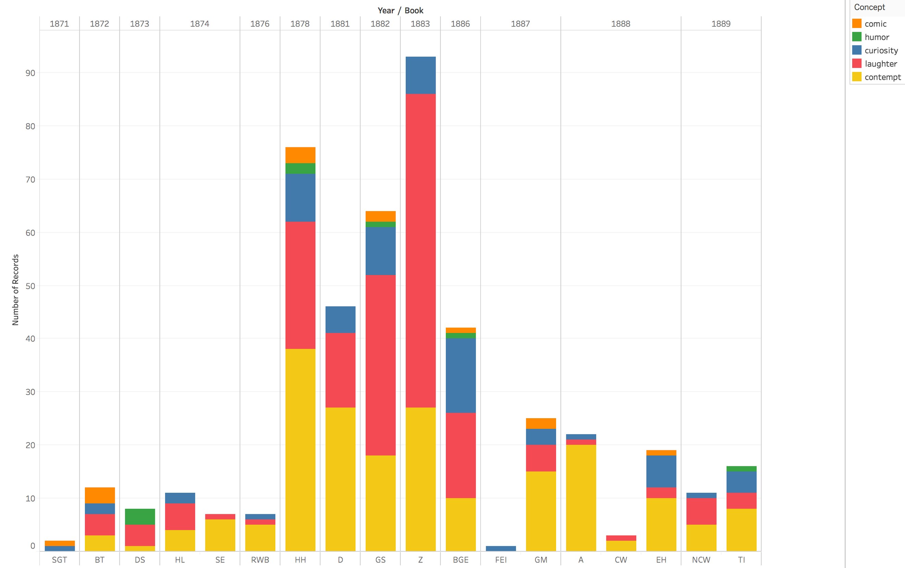

As Figure 1 shows, Nietzsche demonstrates relatively little engagement with contempt, laughter, and curiosity until 1878, when he publishes Human, All-Too-Human. He continues to demonstrate interest in these concepts in Daybreak, The Gay Science, Thus Spoke Zarathustra, and Beyond Good and Evil. After 1886, however, his engagement drops off. This suggests that, while interpreters have been right to attend to Zarathustra, they have largely neglected some primary sources, especially Human, All-Too-Human.
Next, consider Figure 2, which shows the relative mixture of engagement with the concepts under study across each of Nietzsche’s books.

Figure 2: all concepts treemap
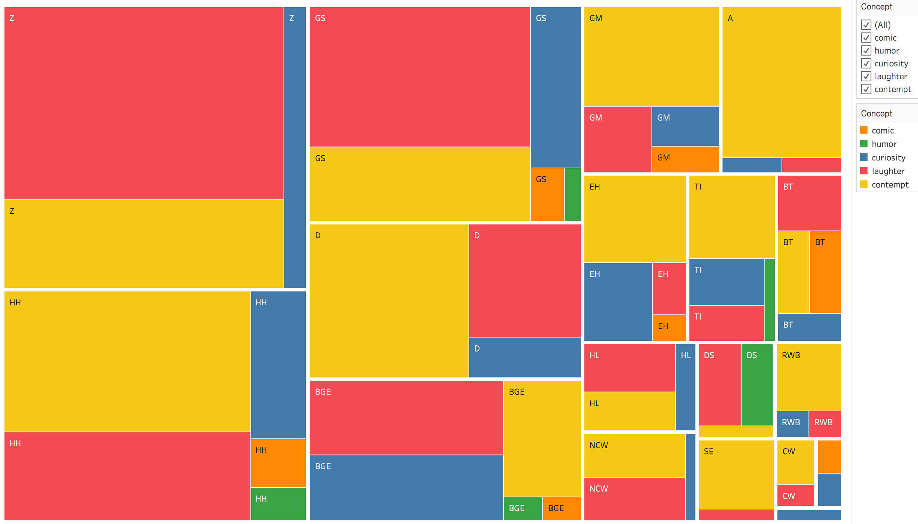

Laughter receives more engagement than any of the other concepts under study in Zarathustra, The Gay Science, Beyond Good and Evil, and The Uses and Disadvantages of History for Life. By contrast, Human, All-Too-Human, Daybreak, The Genealogy of Morals, Ecce Homo, Twilight of the Idols, and The Antichrist engage most with contempt.
Next, consider Figure 3, which shows Nietzsche’s passage-by-passage engagement with concepts of interest in the first half of The Gay Science. We can see, for example, that Nietzsche discusses contempt and laughter together in sections 3 and 84, laughter and humor together in section 49, and laughter and curiosity together in section 85. At the website associated with this paper, it is possible to see an interactive visualization of the rest of The Gay Science as well as each of the other books analyzed in this study. These visualizations make it easy to determine in a glance which passages are likely to best illuminate how Nietzsche conceives of laughter, contempt, and curiosity, as well as how he relates them.

Figure 3: relevant passages from The Gay Science
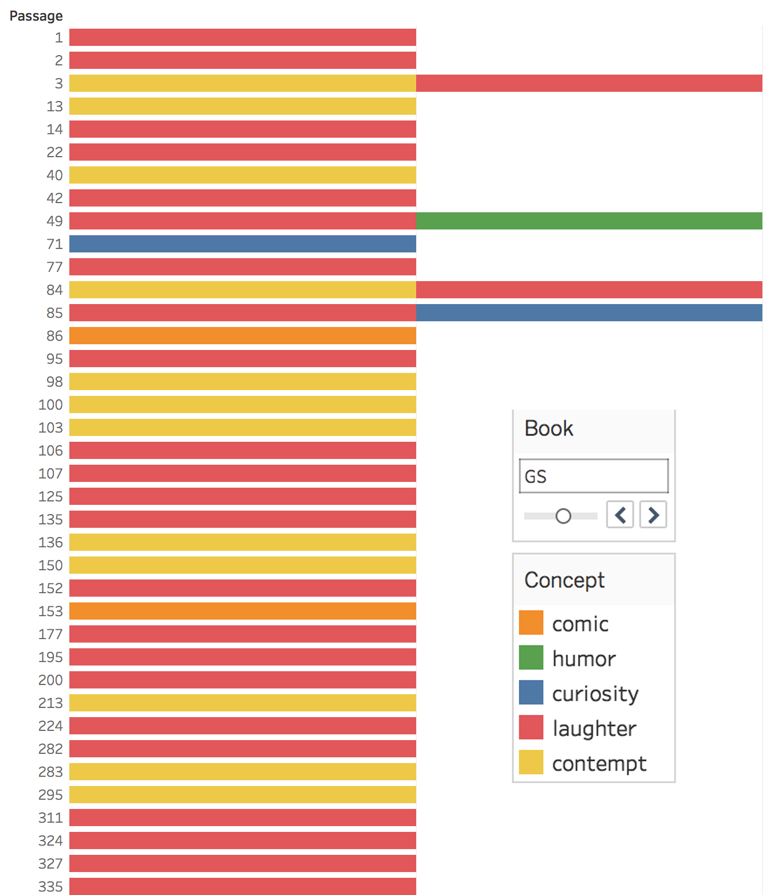

Finally, consider Figure 4, which maps the overlaps among the concepts under study.

Figure 4: Venn diagram of Nietzsche’s use of contempt, curiosity, and laughter, representing the number of passages in which a combination of concepts is discussed.
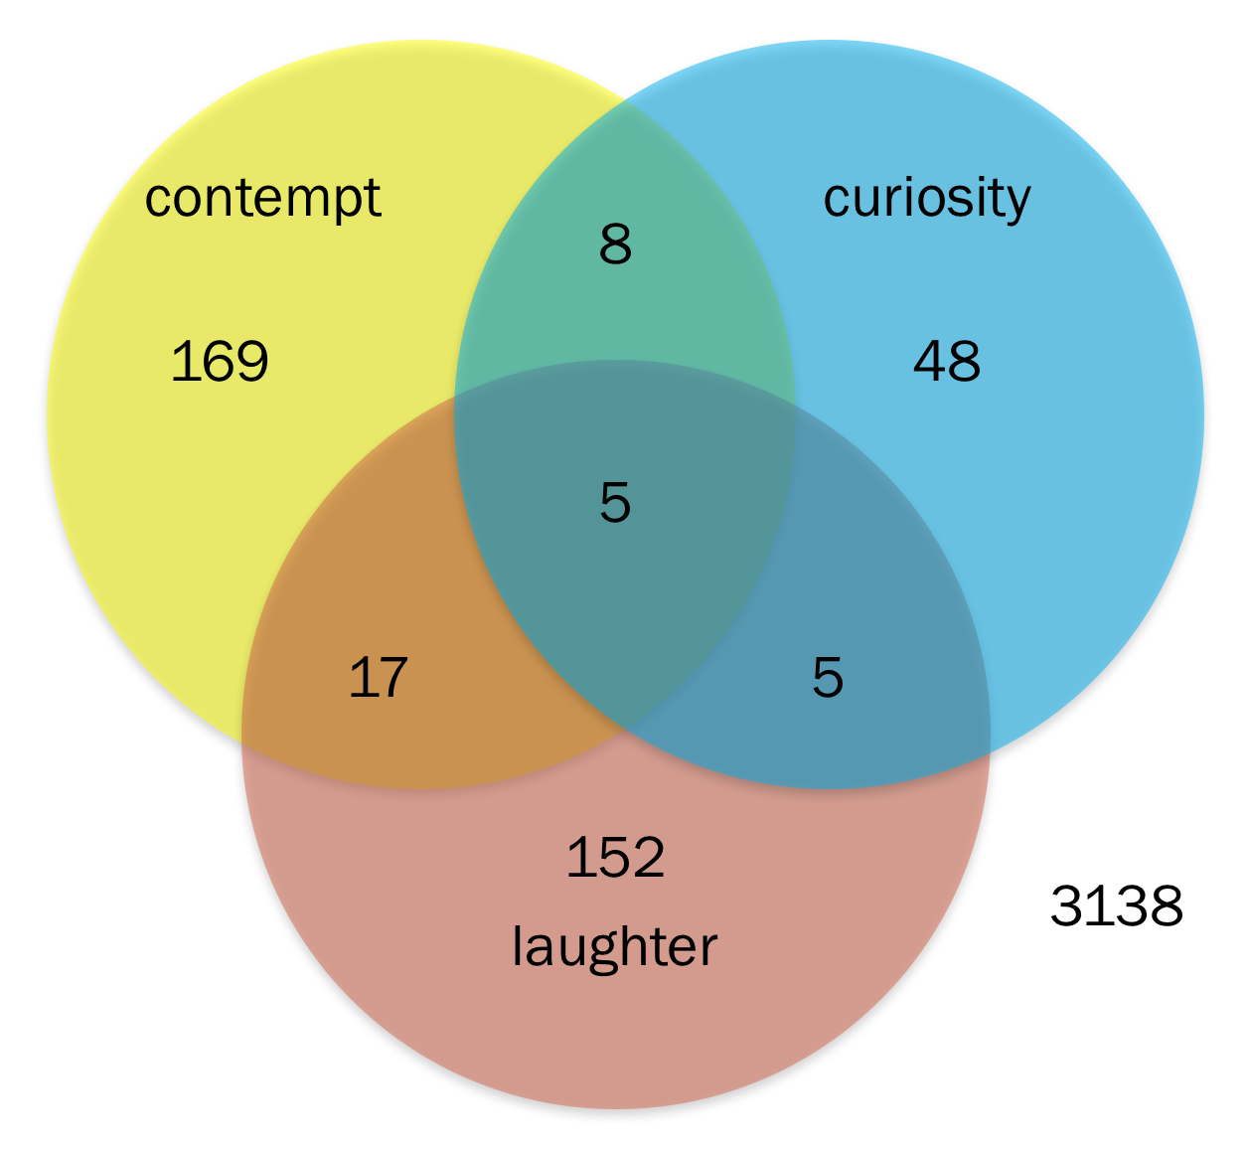

Figure 4 is a Venn diagram, which Tableau Public does not support, so I constructed it manually. This diagram shows that there are 169 passages in which Nietzsche refers to contempt but neither curiosity nor laughter, 8 passages in which he refers to contempt and curiosity but not laughter, 17 passages in which he refers to contempt and laughter but not curiosity, and 5 in which he refers to all three.
In addition to visualizations, we can also calculate some basic statistics about these texts. Doing so enables us to conclude that Nietzsche is significantly more likely to refer to one of the concepts under study if he also refers to at least one of the other two. Consider contempt by way of example. There are 3542 total passages in the works under consideration, of which 199 refer to contempt. The probability that a randomly selected passage will refer to contempt is therefore 199/3542 = 5.618%. There are 235 passages that refer to curiosity or laughter, of which 30 also refer to contempt. The conditional probability that a randomly selected passage that refers to at least one of the other concepts will also refer to contempt is therefore 30/235= 12.766%. The discrepancies are similar for the other concepts. The prior probability of a randomly selected passage referring to curiosity is 66/3542 = 1.863%, while the conditional probability of a passage referring to curiosity given that it refers to at least one of the other two concepts is 5.056%. The prior probability of laughter is 5.054%, while the conditional probability is 10.714%. Generalizing, the probability of one of these terms occurring in a passage is more than doubled if at least one of the other terms occurs in the same passage. Not to put too fine a point on it: these concepts are strongly related in Nietzsche’s thinking.

Interpretation
In this section, I offer an interpretation of Nietzsche’s conceptions of contempt, curiosity, and laughter based on key passages identified through the methodology sketched above. Visualizations and basic statistics are food for thought. They do not do the interpretive work themselves. Nevertheless, by providing a synoptic view of the texts to be interpreted and hinting at connections between concepts, they can guide our reading. Determining more precisely how the concepts are related, however, demands close-reading that is attentive to the possibility of changes in Nietzsche’s view from the free spirit works to the mature works, alertness to his use of irony and sarcasm, and an eye to the linguistic context in which a term crops up. In what follows, I will argue that Nietzsche tactically uses humor and laughter for epistemic purposes. His epistemic aims include enabling inquiry (when faith and reverence might have forbidden it), achieving knowledge (for himself or for his reader), and abandoning error (again for himself or for his reader). Humor supports these goals by inducing contempt and the laughter that expresses (and sometimes also conjures) it.
Laughter strengthens bonds between people. When we laugh together, we strengthen our sense of community (Dezecache & Dunbar 2012, Curry & Dunbar 2013). This is in part just because, as Nietzsche observes in HH 1.216, laughing together is pleasant, but there’s more to the story. Laughing together is also an indication of shared mindset and values. And because laughter typically arises spontaneously in reaction to eliciting conditions, laughter is a difficult-to-fake, difficult-to-stifle expression of what one does and does not value. In HH Opinions 276, Nietzsche claims that people who have acquired cultivated tastes and dispositions still give away their background when they laugh. And in GS 282, he says that he finds it “laughable” when “even great minds betray that they come from the mob or half-mob” by the unconscious style of their writing. More contentiously, I want to suggest that at least some laughter arises from adopting an affective and evaluative perspective from which the target of laughter is risible or contemptible, a position Nietzsche holds in, among other passages, HH 1.372, HH Wanderer 123, D 41, D 291, GS 200, Z Teachers, BGE 62, and GM III.3. If this is on the right track, then finding out that someone else finds all and only the same things contemptible as you do is strong evidence that you two will get along, which helps to explain Nietzsche’s one-liner in GS 177: “In Germany, higher men lack one great means of education: the laughter of higher men; for in Germany, these do not laugh.”
But laughter also severs bonds between people. Imagine having dinner with a small group of people. One of them cracks wise in a way that you find distasteful or offensive. The rest of the group bursts into guffaws as you sit stony and silent. Not being in on the joke is alienating. And of course, being the butt of the joke – unless you’ve learned to laugh at yourself – can be even more alienating. This is in part simply because it’s generally unpleasant to be the object of contempt, but it’s also because being left out of the community of laughter indicates that you don’t share the mindset or values of that community.
If this is right, then laughter simultaneously strengthens some social bonds while severing others. This is one of the reasons why we need to analyze laughter as a complex social phenomenon, as I indicated above. Laughing together at someone or something is liable to make the laughers more confident in their own mindset and values and to undermine any confidence they had in the mindset and values associated with the target of their laughter. The target is liable to appear nonsensical or not worthy of being taken seriously. In a passage titled “The key” (HH 1.183), Nietzsche writes, “A man of significance may set great store by an idea and all the insignificant laugh and mock at him for it: to him it is a key to hidden treasure-chambers, while to them it is no more than a piece of old iron.” Nietzsche here suggests that we laugh at things that make no sense to us, and that we would stop laughing if we were suddenly to understand. In this passage, as well as D 76, D 210, GS 3, and BGE 223, Nietzsche also suggests that the path between laughter and nonsense is a two-way street. In addition to responding to nonsense with laughter, we sometimes start to find something ridiculous by laughing at it. For instance, in D 210, he begins by distinguishing the question “what is laughable?” from “what is laughter?” He then goes on to claim that nothing is laughable in itself, “but there are states of soul in which we impose such words upon things external to and within us.” Thus, the property of being ridiculous is imputed by ridiculing and laughing.
As I argued in Alfano (2010, 2013b), Nietzsche thinks that certain cognitive or doxastic states have a kind of tenacity or staying power. Even in the face of strong counter-evidence, we tend not to revise or abandon such beliefs. Furthermore, when we do revise them, we tend to do so in irrational ways. This problem arises especially in connection with what Buckwalter et al. (2013) call “thick,” beliefs, which are imbued with emotion. For Nietzsche, thick beliefs are often associated with trust or faith, though they can also be associated with non-epistemic emotions. Laughter that expresses contempt – even if only briefly – dislodges or shakes loose affectively-tinged doxastic states that would otherwise be hard or impossible to revise or reject – or even review. As Zarathustra puts it, “Not by wrath does one kill, but by laughing” (Z Reading). This is the first epistemic function of contempt and laughter in his philosophy.
For example, in HH Wanderer 213, Nietzsche stages a dialogue between an “old man” and Pyrrho the skeptic. Pyrrho first says he is not only going to lie but also announce to his audience that he will lie. This is allegedly Pyrrho’s way of teaching skepticism. The old man questions the prudence of this strategy, to which Pyrrho responds by committing to mistrust of both words and silence. The old man then asks whether Pyrrho understands himself anymore, to which Pyrrho responds by turning away and laughing. “The old man: Alas, friend! Laughing and staying silent – is that now your whole philosophy? – Pyrrho: It wouldn’t be the worst one.” In this passage, Pyrrho manages to give up on his commitment to teaching skepticism by laughing contemptuously at his own plan. Throughout Nietzsche’s texts, we see similar psychological dynamics. In GS 335, he dismisses the categorical imperative, saying, “The term tickles my ear and makes me laugh despite your very serious presence.” In GS 346, he writes
The whole attitude of ‘man against the world’, of man as a ‘world-negating’ principle, of man as the measure of the value of things, as judge of the world who finally places existence itself on his scales and finds it too light – the monstrous stupidity of this attitude has finally dawned on us and we are sick of it; we laugh as soon as we encounter the juxtaposition of ‘man and world’, separated by the sublime presumptuousness of the little word ‘and’! But by laughing, haven’t we simply taken contempt for man one step further?
He then goes on to suggest that such contemptuous laughter destroys veneration, and without anything to venerate one is liable to fall into nihilism. Laughter is thus both a cause of and a cure for nihilism. It enables people to give up their most cherished beliefs, which can lead pretty directly to nihilism, but it also helps them maintain a positive affective disposition, which keeps nihilism at bay.
The theme of destroying beliefs associated with veneration or religious emotion also crops up in Z (Apostates 2), where Zarathustra reports that
It has been over for the old gods for a long time now – and truly, they had a good cheerful gods’ end! They did not ‘twilight’ themselves to death – that is surely a lie! Instead, they just one day up and laughed themselves to death! This happened when the most godless words were uttered by a god himself – the words: ‘There is one god. Thou shalt have no other god before me!’
Likewise, Nietzsche dismisses Kant’s Critique of Pure Reason with incisive laughter in BGE 11 (see also GM III.6 and TI Socrates 5):
‘How are synthetic judgments a priori possible?’ Kant asked himself – and what really is his answer? ‘By virtue of a faculty’ – but unfortunately not in five words, but so circumstantially, venerably, and with such a display of German profundity and curlicues that people simply failed to note the laughable [lustige] niaiserie allemande involved in such an answer. […] One can do no greater wrong […] than to take it seriously.
Like most philosophers, Nietzsche offers reasons and arguments for his positions; unlike most other philosophers, he tries to cement his reasoning and argumentation rhetorically by inducing laughter at his targets. If these targets are seen as ridiculous and nonsensical, his audience is more likely to be moved.
In addition to helping people to give up thick but erroneous beliefs, contempt and laughter enable inquiry in the first place. This is an essential first step in Nietzsche’s curiosity-based epistemology and arguably an essential first step for creatures like us more generally, given our inclination to engage in motivated inquiry (Kahan et al. forthcoming). There are at least two ways in which this works. First, in HH 1.372, Nietzsche argues that contemptuous irony at one’s students can be a “pedagogic tool […]: its objective is humiliation, making ashamed, but of that salutary sort which awakens good resolutions.” Directing laughter at one’s student’s belief or argument can, if they are able to laugh at themselves, lead them to conduct more responsible inquiry. It functions as a prod to epistemic agency.
Second, and more importantly, an enduring theme in Nietzsche’s philosophy is that there are some truths that people find hard to accept or even consider. These include unflattering truths of moral psychology as well as truths about religion (i.e., that there is no god) and human mortality. For many people, inquiring at all – let alone successfully – about such truths is opposed by tender feelings, veneration, and faith. Faith is “a veto on science” because it involves “not wanting to know the truth” (A 52). The faithful person prefers to terminate investigation, a point on which Nietzsche and philosophers of religion agree (Buchak 2012). Compassion for hurt feelings – whether one’s own or those of others – constrains inquiry into the terrible truths that Nietzsche finds so fascinating (BT 3, GM I.1, EH Destiny 1, EH Destiny 5, TI Reason 6; see Leiter forthcoming). In order to overcome this opposition, Nietzsche thinks, we sometimes need to laugh at our faith, the objects of our veneration, and our own tender feelings. This is why he says that, “In a man of knowledge, pity is almost laughable, like delicate hands on a cyclops” (BGE 171). In a passage about a free spirit who is in the process of breaking free from his current value-set and sense of obligation (HH P 3), Nietzsche says,
With a wicked laugh he turns round whatever he finds veiled and through some sense of shame or other spared and pampered: he puts to the test what these things look like when they are reversed. It is an act of willfulness, and pleasure in willfulness, if now he perhaps bestows his favour on that which has hitherto had a bad reputation – if, full of inquisitiveness and the desire to tempt and experiment, he creeps around the things most forbidden. Behind all his toiling and weaving […] stands the question-mark of a more and more perilous curiosity.
Here we see laughter and contempt for tender feelings put to the service of a kind of cruel curiosity that aims to reveal the most shameful things about humanity.
Accepting the terrible truths without falling into nihilism also requires laughter. In section 7 of the “Attempt at Self-criticism” that Nietzsche appended to The Birth of Tragedy, he sheepishly admits that much of the book is nonsense, but he maintains a commitment to a kind of cheerful pessimism that, he says, prevents nihilism. He goes on to recommend the same kind of cheerful pessimism to his audience and critics, telling them, “You should first learn the art of comfort in this world, you should learn to laugh my young friends, if you are really determined to remain pessimists.” Such laughter inures the laugher against nihilism, which is one of the reasons why Nietzsche insists that his philosophy can be aptly described as gay science. One might worry that laughter, because it expresses contempt and a judgment that something is nonsense, is in tension with effective inquiry. Nietzsche thinks otherwise, as he says in GS 327: “And ‘where laughter and gaiety are found, thinking is good for nothing’ – that is the prejudice of this serious beast against all ‘gay science’. Well then, let us prove it a prejudice!”
If this interpretation is on the right track, then Nietzsche envisions multiple epistemic functions for contempt and laughter. It prompts the revision or rejection of erroneous thick beliefs. It negates the inquiry-halting effects of faith and pity (including pity for oneself). It buoys the spirits of those who accept terrible truths and might otherwise fall into nihilism. Two final epistemic functions of laughter are the opening up of imaginative possibilities and the promotion of self-knowledge. In other work (Alfano 2017), I show that Nietzsche appropriated the Christian tradition of distinguishing spernere mundum (contempt for the world), spernere neminem (contempt for no one), spernere se ipsum (contempt for self), and spernere se sperni (contempt for being contemned). If we bring this distinction to contempt-expressing laughter, then we should expect Nietzsche to distinguish functions for laughter in connection with this taxonomy of contempt.
Spernere mundum is most closely linked with the puzzling virtue of solitude that Nietzsche often celebrates (HH P 3, HH 1.625, HH Wanderer 62, D 2, D 249, D 443, BGE 284, GM III.14, EH Wise 8). By solitude he does not mean being physically isolated. Instead, he has in mind the kind of alienation that occurs when one finds oneself out of step with one’s community. This is the kind of alienation that occurs when everyone else is laughing, or when you’re laughing while everyone else is stone-faced. Spernere mundum makes it possible to value differently, to adopt a different mindset from the norm in one’s community – no mean feat for members of a species deeply inclined towards group polarization and blind acceptance of whatever one’s community endorses (Sunstein 2002). Spernere se sperni amps up this disposition because it frees one to laugh not only at one’s community and their values but also at one’s own subsequent ostracism from that community. Finally, spernere se ipsum enables one to laugh contemptuously at oneself, which in turn makes it possible to see one’s own negative qualities and also to change psychologically. I mentioned above that Zarathustra laughs at himself and recommends laughter at oneself to the wrecks of the higher men. Nietzsche also discusses reflexive laughter in HH 1.137, a passage about self-defiance and self-overcoming. He argues that some people take “real delight in oppressing themselves with excessive claims and afterwards idolizing this tyrannically demanding something in their soul.” Such self-overcoming leads to various seemingly foolhardy endeavors: “Thus a man climbs on dangerous paths in the highest mountains so as to laugh mockingly at his fears and trembling knees; thus a philosopher adheres to views of asceticism, humility, and holiness in the light of which his own image becomes extremely ugly.” In the same vein, in GS 107 Nietzsche says, “At times we need to have a rest from ourselves by looking at and down at ourselves and, from an artistic distance, laughing at ourselves or crying at ourselves; we have to discover the hero no less than the fool in our passion for knowledge; we must now and then be pleased about our folly in order to be able to stay pleased about our wisdom.” And in GS 1, he offers this somewhat perplexing challenge:
you will never find someone who could completely mock you, the individual, even in your best qualities, someone who could bring home to you as far as truth allows your boundless, fly- and frog-like wretchedness! To laugh at oneself as one would have to laugh in order to laugh from the whole truth – for that, not even the best have had enough sense of truth, and the most gifted have had far too little genius!

Conclusion: Having a sense of humor as a virtue

In this brief concluding section, I want to broach a possibility that takes us beyond interpreting Nietzsche: might having a sense of humor constitute a virtue, and if it does, how should we characterize that virtue? In BGE 25, Nietzsche complains about philosophers who respond to terrible truths with “moral indignation,” saying that this is “the unfailing sign in a philosopher that his philosophical sense of humor has left him.” Later, in BGE 294, he goes further, saying,
I should actually risk an order of rank among philosophers depending on the rank of their laughter – all the way up to those capable of golden laughter. And supposing that gods, too, philosophize, which has been suggested to me by many an inference – I should not doubt that they also know how to laugh the while in a superhuman and new way – and at the expense of all serious things. Gods enjoy mockery: it seems they cannot suppress laughter even during holy rites. (BGE 294)
For Nietzsche, a virtue is a drive – whether innate or acquired – that is well-calibrated to both the rest of the agent’s psychology and to their material and social environment (Alfano forthcoming b). Drives are individuated by the signature of emotions they lead their bearer to express. I’ve argued elsewhere that Nietzsche endorses a virtue associated with contempt (and disgust), which he sometimes calls the pathos of distance (Alfano 2017), and a virtue associated with curiosity (Alfano 2013a). We saw above that he also sometimes calls solitude a virtue. My suggestion here is that, for Nietzsche and others disposed to laughter and contempt, having a sense of humor can be another virtue.
This possibility has also been raised by Harry Frankfurt (2001), John Lippett (2005), Adam Morton (2013), and Robert Roberts (1988). Roberts in particular argues that being able to laugh at oneself is essential to self-transcendence, which is involved in many virtues. Although Roberts approaches the question from a Christian point of view, he ends up agreeing with Nietzsche that one of the most important targets of laughter is oneself – in the service of what Roberts calls self-transcendence and Nietzsche calls self-overcoming.

References:
Alfano, M. (2010). The tenacity of the intentional prior to the Genealogy. Journal of Nietzsche Studies, 40: 123-40.
Alfano, M. (2013a). The most agreeable of all vices: Nietzsche as virtue epistemologist. British Journal for the History of Philosophy, 21(4): 767-90.
Alfano, M. (2013b). Nietzsche, naturalism, and the tenacity of the intentional. Journal of Nietzsche Studies, 44(3): 457-64.
Alfano, M. (2017). A schooling in contempt: Emotions and the pathos of distance. In P. Katsafanas (ed.), Routledge Philosophy Minds: Nietzsche. Routledge.
Alfano, M. (forthcoming a). Digital humanities for history of philosophy: A case study on Nietzsche. In T. Neilson, L. Levenberg, D. Rheams, & M. Thomas (eds.), Handbook of Methods in the Digital Humanities. Rowman & Littlefield.
Alfano, M. (forthcoming b). Virtue in Nietzsche’s drive psychology. In T. Stern (ed.), The New Cambridge Companion to Nietzsche. Cambridge University Press.
Ansell-Pearson, K. (1994). An Introduction to Nietzsche as Political Thinker: The Perfect Nihilist. Cambridge University Press.
Buchak, L. (2012). Can it be rational to have faith? In J. Chandler & V. Harrison (eds.), Probability in the Philosophy of Religion. Oxford University Press.
Buckwalter, W., Rose, D., & Turri, J. (2015). Belief through thick and thin. Nous, 49(4): 748-75.
Curry, O. & Dunbar, O. (2013). Sharing a joke: The effects of a similar sense of humor on affiliation and altruism. Evolution and Human Behavior, 34: 125-9.
Deen, P. (2016). What moral virtues are required to recognize irony? Journal of Value Inquiry, 50: 51-67.
Dezecache, G. & Dunbar, R. (2012). Sharing the joke: The size of natural language groups. Evolution & Human Behavior, 33(6): 775-9.
D’Iorio, P. (2010). The digital critical edition of the works and letters of Nietzsche. Journal of Nietzsche Studies, 40: 70-80.
Frankfurt, H. (2001). The dear self. Philosophers’ Imprint, 1(0): 1-14.
Freud, S. (1905 / 1974). Jokes and Their Relation to the Unconscious, J. Strachey (tr.). Penguin.
Gemes, K. (2001). Postmodernism’s use and abuse of Nietzsche. Philosophy and Phenomenological Research, 62(2): 337-60.
Gemes, K. (2008). Nihilism and the affirmation of life: A review of and dialogue with Bernard Reginster. European Journal of Philosophy, 16(3): 459-66.
Gordon, M. (2016). Camus, Nietzsche, and the Absurd: Rebellion and scorn versus humor and laughter. Philosophy and Literature, 39(2): 364-78.
Hatab, L. (1988). Laughter in Nietzsche’s thought. International Studies in Philosophy, 20(2): 67-79.
Higgins, K. (1994). On the Genealogy of Morals – Nietzsche’s gift. In R. Schacht (ed.), Nietzsche, Genealogy, Morality: Essays on Nietzsche’s Genealogy of Morals. University of California Press.
Higgins, K. (2000). Comic Relief: Nietzsche’s Gay Science. Oxford University Press.
Hobbes, T. (1651 / 1982). Leviathan. Penguin.
Kahan, D., Dawson, E., Peters, E., & Slovic, P. (forthcoming). Motivated numeracy and enlightened self-government. The Cultural Cognition Project, working paper #116.
Kant, I. (1790 / 1911). Critique of Judgment, J. C. Meredith (tr.). Clarendon Press.
Kuipers, G. (2008). The sociology of humor. In V. Raskin (ed.), The Primer of Humor Research. De Gruyter.
Leiter, B. (forthcoming). The truth is terrible. In D. Came (ed.), Nietzsche on Morality and the Vale of Life. Oxford University Press.
Lippitt, J. (1992). Nietzsche, Zarathustra, and the status of laughter. British Journal of Aesthetics, 32(1): 39-49.
Lippitt, J. (2005). Is a sense of humor a virtue? The Monist, 88(1): 72-92.
More, N. (2014). Nietzsche’s Last Laugh: Ecce Homo as Satire. Cambridge University Press.
Moretti, F. (2013). Distant Reading. Verso.
Morreall, J. (1983). Taking Laughter Seriously. SUNY Press.
Morreall, J. (2016). Philosophy of humor. In E. Zalta (ed.), The Stanford Encyclopedia of Philosophy. URL = <https://plato.stanford.edu/archives/win2016/entries/humor/>.
Morton, A. (2013). Emotion and Imagination. Polity.
Pappas, N. (2005). Morality gags. The Monist, 88(1): 52-71.
Reginster, B. (2013). Honesty and curiosity in Nietzsche’s free spirit. Journal of the History of Philosophy, (3): 441-63.
Roberts, R. (1988). Humor and the virtues. Inquiry, 31(2): 127-49.
Scruton, R. (1986). Laugher. In J. Morreall (ed.), The Philosophy of Laughter and Humor. SUNY Press.
Sunstein, C. (2002). The law of group polarization. Journal of Political Philosophy, 10(2): 175-95.
Weeks, M. (2004). Beyond a joke: Nietzsche and the birth of “super-laughter.” Journal of Nietzsche Studies, 27(1): 1-17.
Wirth, J. (2005). Nietzsche’s joy: On laughter’s truth. Epoché, 10(1): 117-39.

I use the standard abbreviations for the titles of Nietzsche’s texts (http://www.hunter.cuny.edu/jns/style-guide). All translations are Cambridge University Press critical editions, with a few minor emendations for clarity.
Search conducted 23 January 2017. Gemes (2001; 2008) makes brief forays into the sort of word-counting that grounds the analysis in this paper, but he does not monitor overlaps. In addition, his papers were written before the Nietzsche Source was available as a resource.
For a full introduction, see D’Iorio (2010).
Available for free download at https://public.tableau.com/en-us/s/download. Tableau Public is a highly intuitive interface that automatically employs best practices in visual analytics.
Note: don’t try this at home.

